The Gold Market is all that remains of what was once a large covered souq filled with tradesman specializing in different areas. The market was originally constructed in 1476AD, during the late Mamluk period, by the Sheikh Shams Al Din Al Himsi. Much of the larger market was destroyed by British bombardment during the First World War, but the Gold Market remains. Small shops line both sides of the street, which is covered with a vaulted roof.

The Market is still a very popular place to deal in gold and currency, and has been for centuries. Many engaged couples still come here to pick out gold jewelry from the many shops. The market sits along the southern wall of the Al Omari Mosque and runs the length of about 60 meters.

El mercado de oro es todo lo que queda de lo que fue un gran zoco cubierto lleno de comerciante especializado en diferentes áreas. El mercado fue construido originalmente en 1476 DC, Durante el tarde período mameluco, por el Sheikh Shams ad-Din Al-Himsi. Gran parte del mercado más grande fue destruida por el bombardeo británico durante la Primera Guerra Mundial, pero sigue siendo el mercado de oro. Las pequeñas tiendas se alinean en ambos lados de la calle, que se cubre con un techo abovedado.

El mercado sigue siendo un lugar muy popular para hacer negocios en oro y divisas, como lo ha sido durante siglos. Muchas parejas comprometidas todavía vienen aquí para escoger y comprar  joyería de oro de las numerosas tiendas. El mercado se encuentra a lo largo de la pared sur de la Mezquita Al-Omari y se extiende  a lo largo de unos 60 metros.

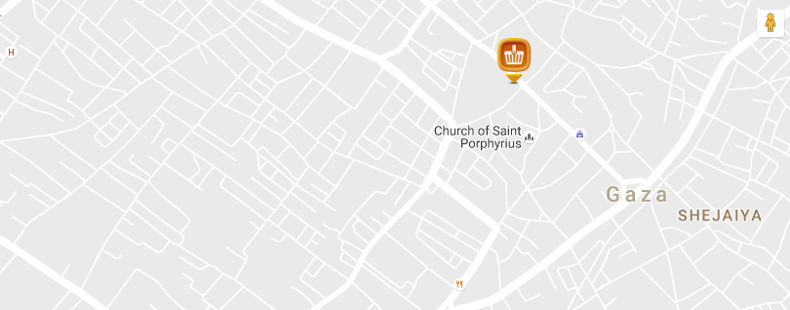

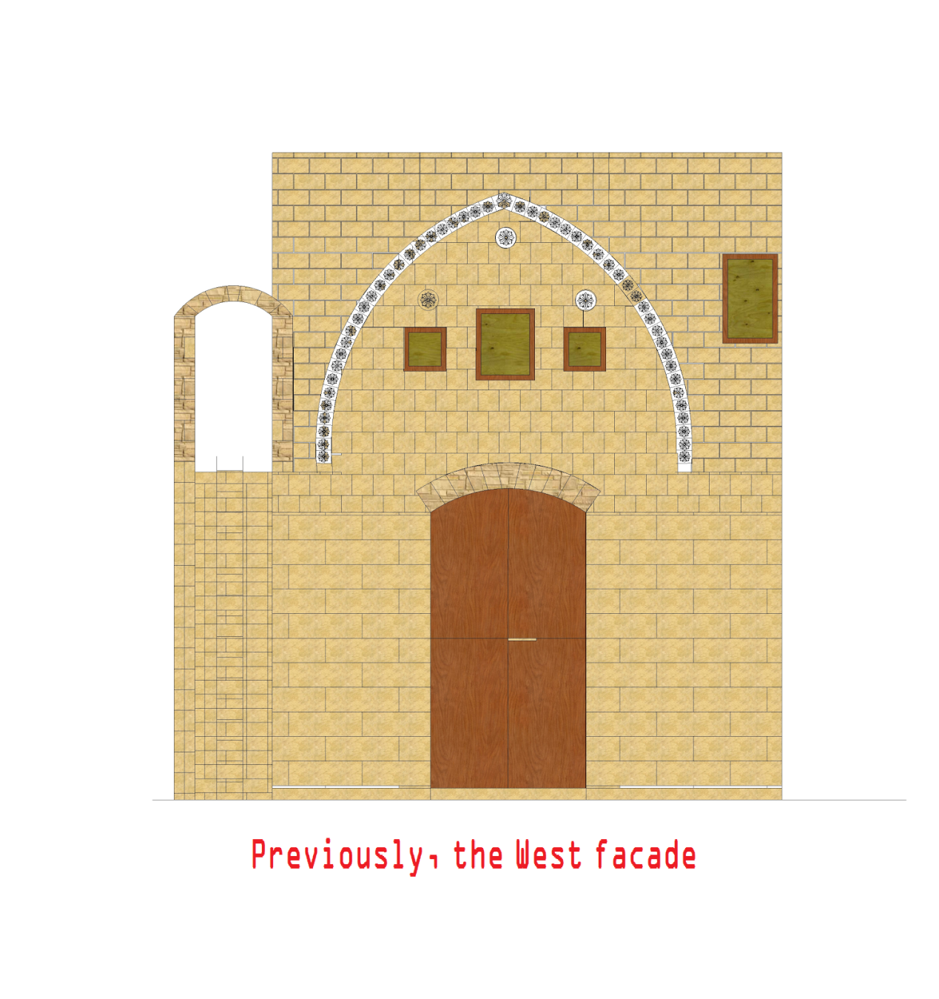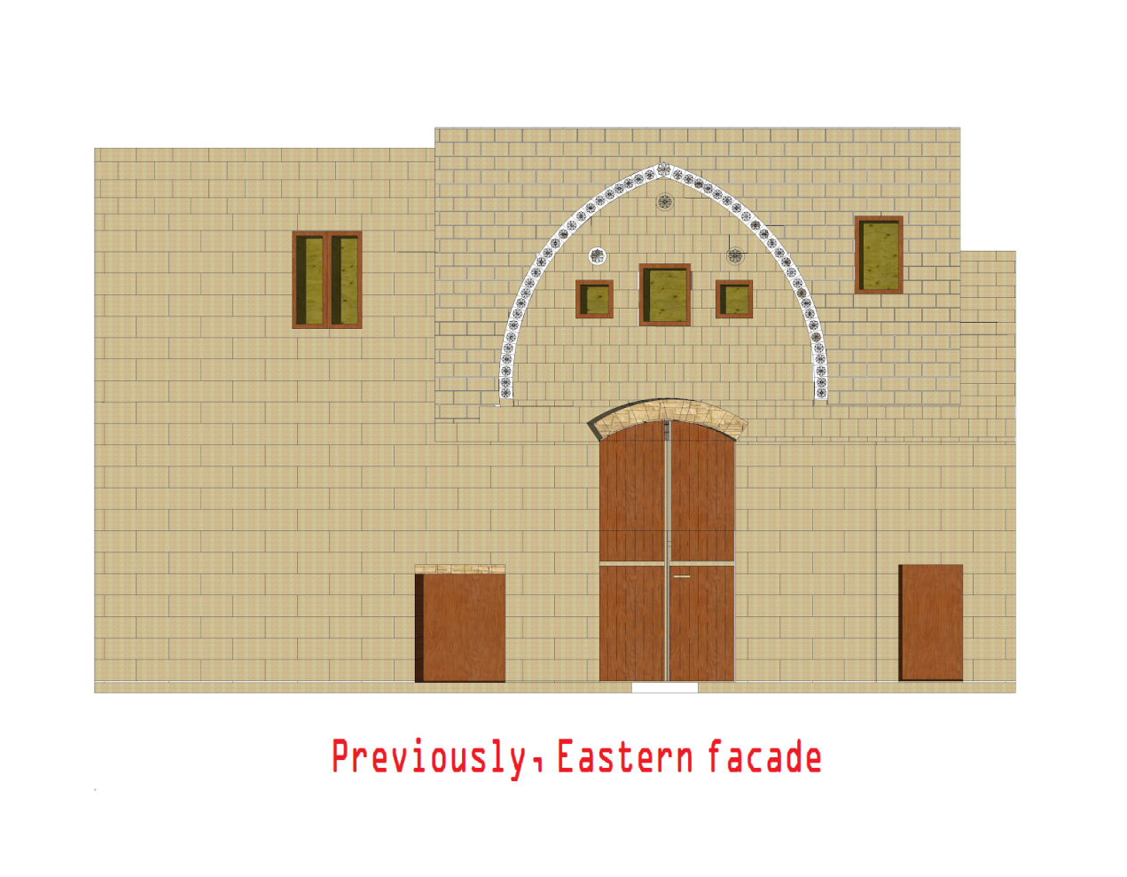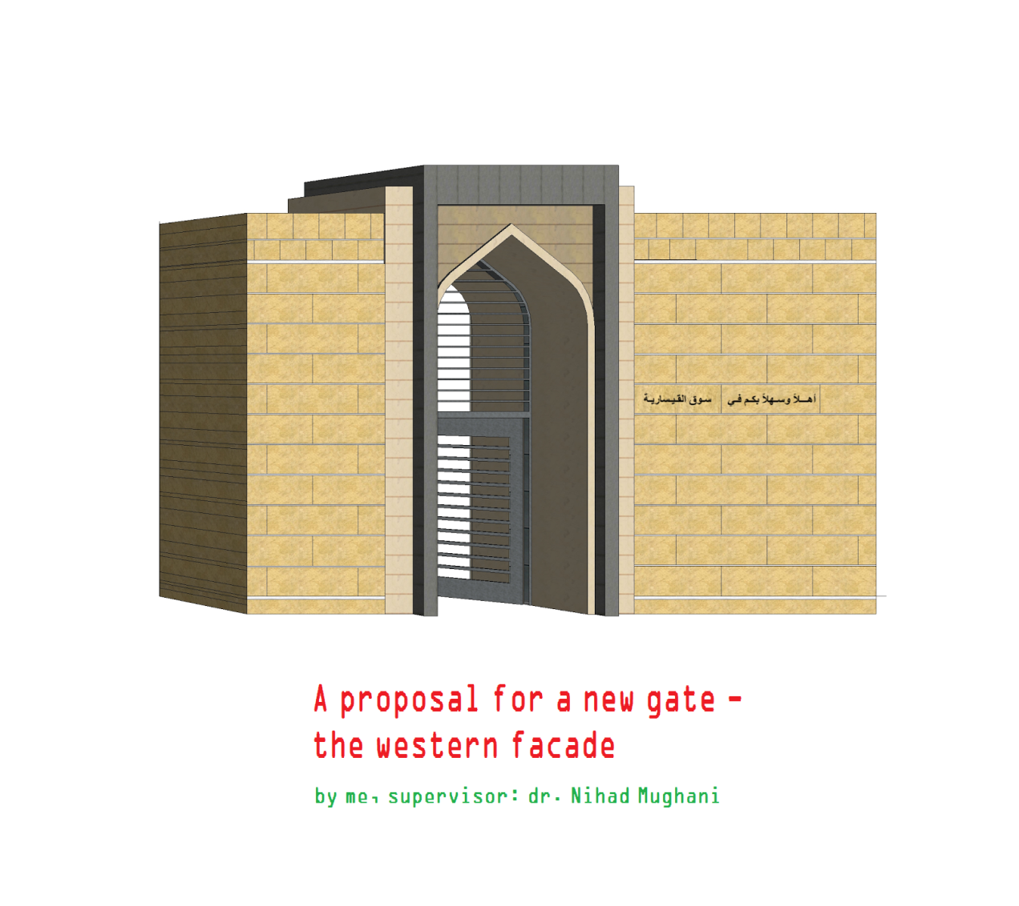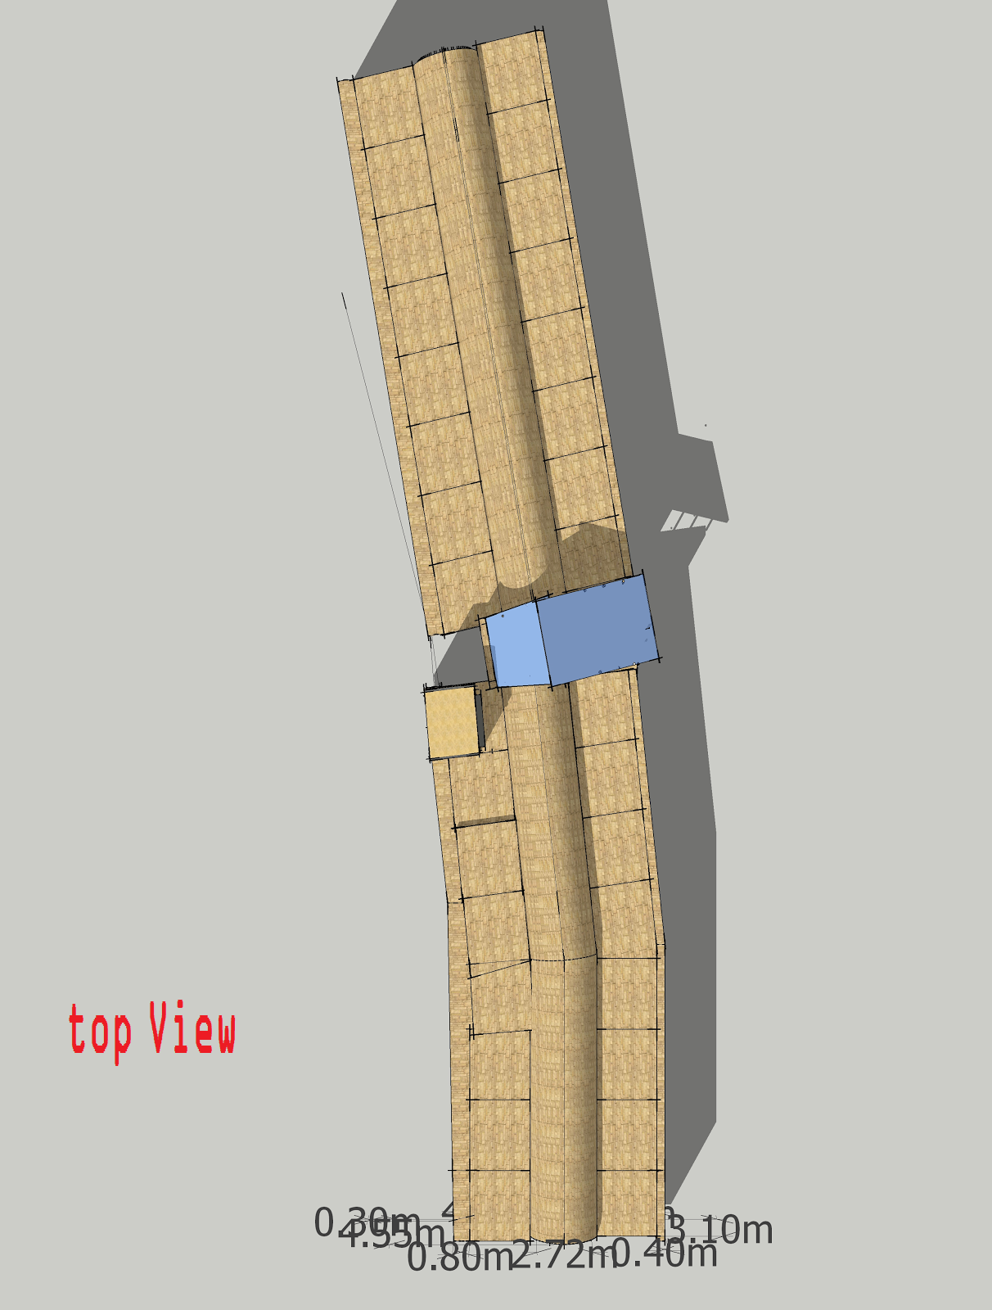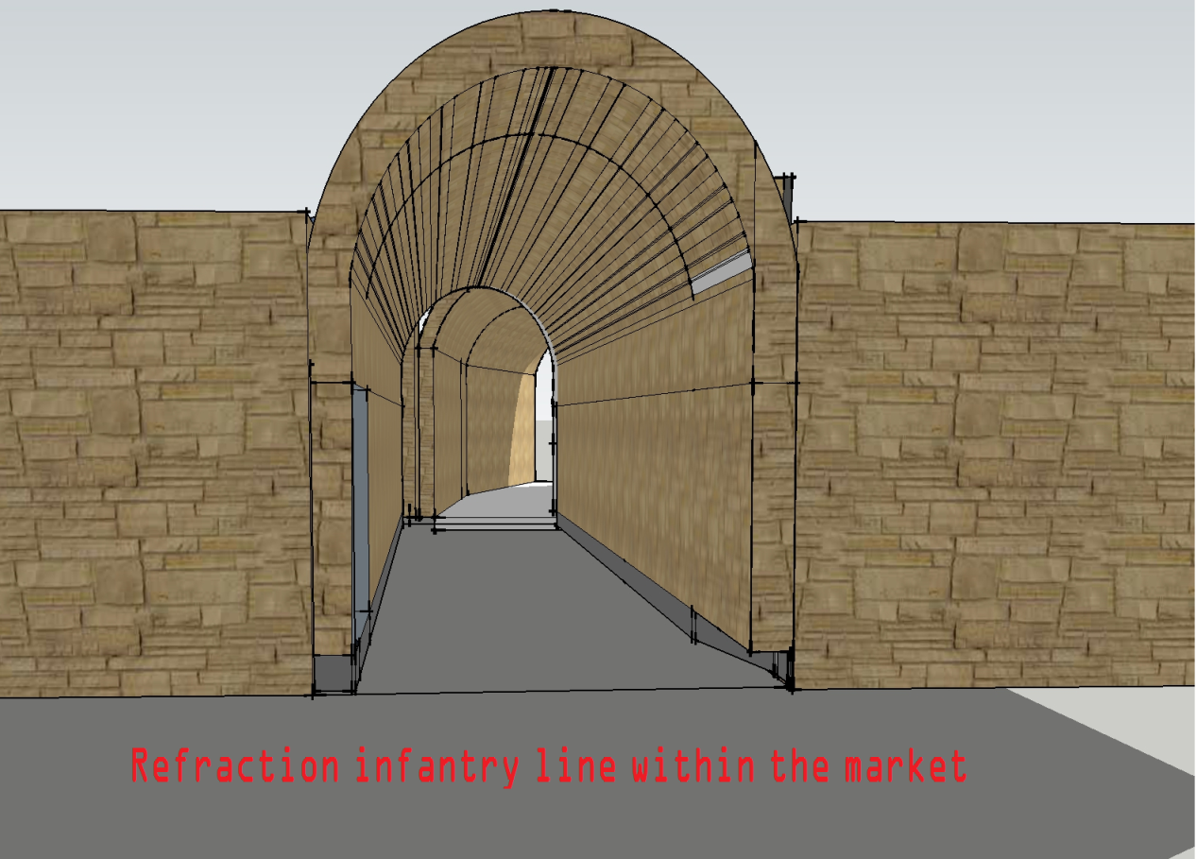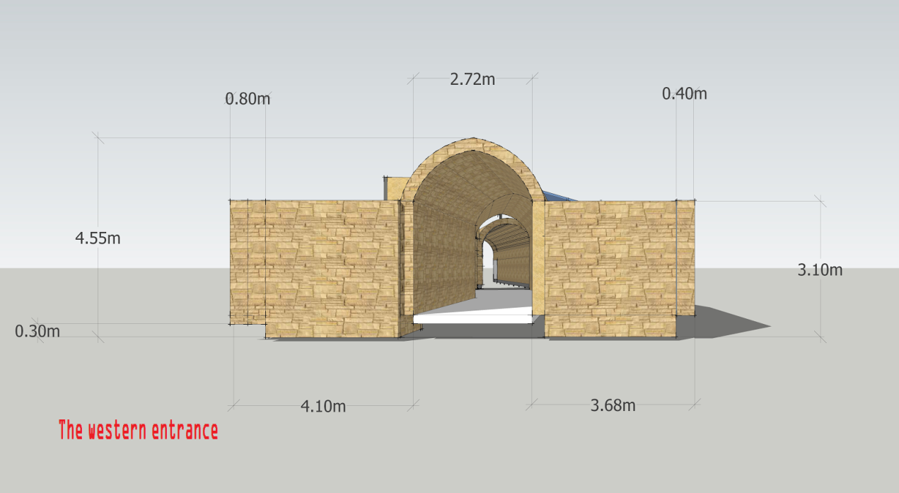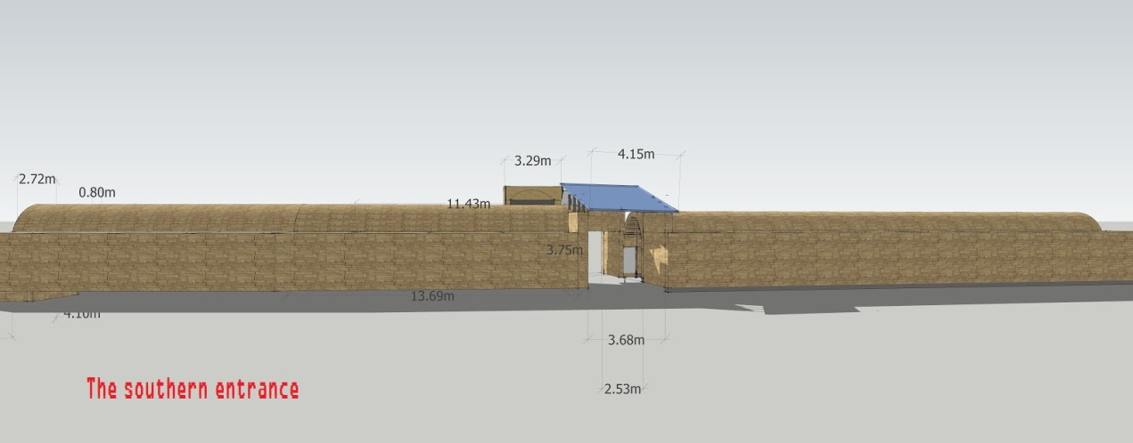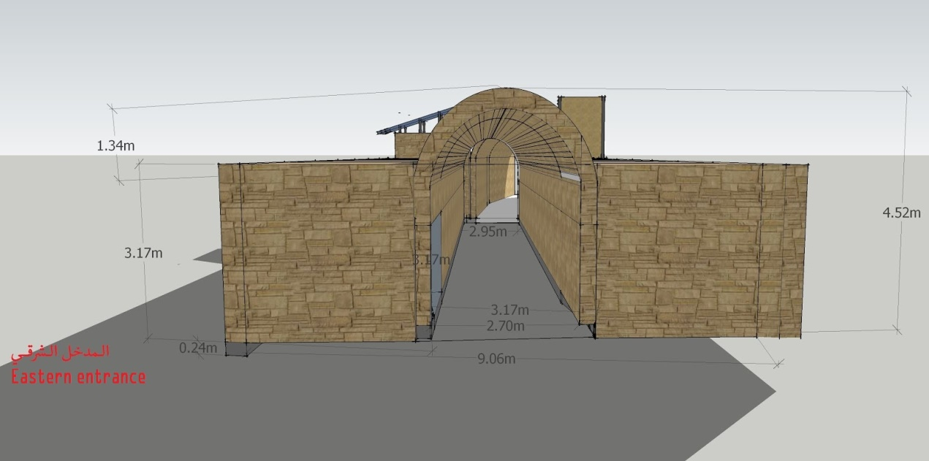

Market qaysariyya:  
  
Located in a neighborhood adjacent to the stairs south wall of the mosque, the great age and build the market back to the Mamluk era and consists of a street covered with a vault and tapered on both sides of the street covered with small shops Boaqbih intersecting called qaysariyya market or the gold market relative to the gold trade.